MANAGING PROCEDURES FOR LUBRICATING OILS

- Quantities and quality (grade) of lube oils onboard are one of important factors for safe navigation of the vessel. The chief engineer must check the remaining lube oils onboard and report the consumption to the Company once a voyage.

- While planning the Lub oils replenishment close co-ordination with company is essential due to varying cost price of Lubes at different ports.

Policy for ROB

        - Main Engine Cylinder Oil -Enough quantity to be maintained on board estimating expected consumption for coming planned voyage, for which daily consumption to be grasped. (including min 10 days extra consumption).

Or quantity consumed for 2 – 3 months to be maintained on board in case expected to call inconvenient Ports for LO supply for a long time.

        - Main Engine System Oil - Enough quantity to be maintained on board estimating expected consumption for coming planned voyage, for which daily consumption to be grasped. (including min 10 days extra consumption)

Or
quantity consumed for 2 – 3 months to be maintained on board in case expected to call inconvenient ports for LO supply for a long time.

Apart from usual consumption, quantity equivalent to full quantity in the system to be maintained in preparation for emergency replenishment resulting from possible troubles.

        - Generator Engine System Oil - Enough quantity to be maintained on board estimating expected consumption for coming planned voyage, for which daily consumption to be grasped. (including min 10 days extra consumption as emergency use)

Or
quantity consumed for 2 – 3 months to be maintained on board in case expected to call inconvenient ports for LO supply for a long time.

Apart from usual consumption, quantity equivalent to full quantity in two (2) G/E system to be maintained in preparation for emergency replenishment resulting from possible troubles.

        - Steering Gear Oil - 80% of spare oil tank capacity attached to steering gear system or quantity equivalent to full quantity in the system, whichever higher to be maintained.

        - Other Oils (Aux. Machineries, Deck Machineries, Greases) - Enough quantity to be maintained on board estimating expected consumption for coming planed voyage, for which daily consumption to be grasped. (including min 10 days extra consumption)

Or
quantity consumed for 2 – 3 months to be maintained on board in case expected to call inconvenient Ports for LO supply for a long time.

Daily checks to be enhanced to mitigate unexpected consumption caused by leaking and so on.

        - If there is any concern about remaining quantity, vessel must report to SI in charge without delay.

Purchasing

        - Bunkering plan to be made in accordance with Policy for ROB and requisition to be submitted to the office well in advance through Ship Serv.

        - There is a big difference in LO price from port to port. Hence, it’s imperative to ensure receiving LO up to full tank capacity regardless of Policy for ROB in case calling ports such as Singapore, Amsterdam and so on where LO prices less.

        - Requisition must be sent well in advance i.e. at least one week advance as lead time for supply is always required, except for emergency cases, but again this will vary on case to case basis.

        - Cases where vessel has requested LO supply, however it cannot be arranged due to inconvenience of supply or unreasonably high prices vessels must closely liaise with Tech SI to reschedule supply.

        - Vessels are requested to always keep close communication with SI in charge not only about LO arrangement but any other concerns as well.

        - LO supply in drums to be avoided as much as possible.

Bulk Supply

        - Procedure for Lub oil supply in bulk is same as fuel oil bunkering. All details as per section 5.2 to 5.5 to be followed.

Quality Test (Sample Test)

        - Sampling Procedure:

          - Sampling point to be always same place and to be clearly marked (e.g. “Sampling Point”).
          - Sample to be taken through air vent of strainer in principle
          - Sample to be taken during system running.
          - New sample bottle to be used in order to avoid contamination with water, foreign object and so on.
          - Sample to be taken after enough draining out until emersion and/or heavy discoloration disappear.
          - Stern tube LO sampling

        - In case of forced circulating system (with pump):
Sample to be taken through strainer air vent pipe.

        - In case of natural circulating system (no pump):
Through bottom checking valve and another point after enough draining out until water, emersion and/or heavy discoloration disappear, then those to be mixed together as the testing sample.

        - Please refer to below piping diagram, 403V and 409V or 414V are sampling points.
(Class Guideline: In the case of natural circulation, the oil is to be sampled from a few points at different levels and all samples are mixed together as testing sample. Ref. after mentioned Drawing as Example.)

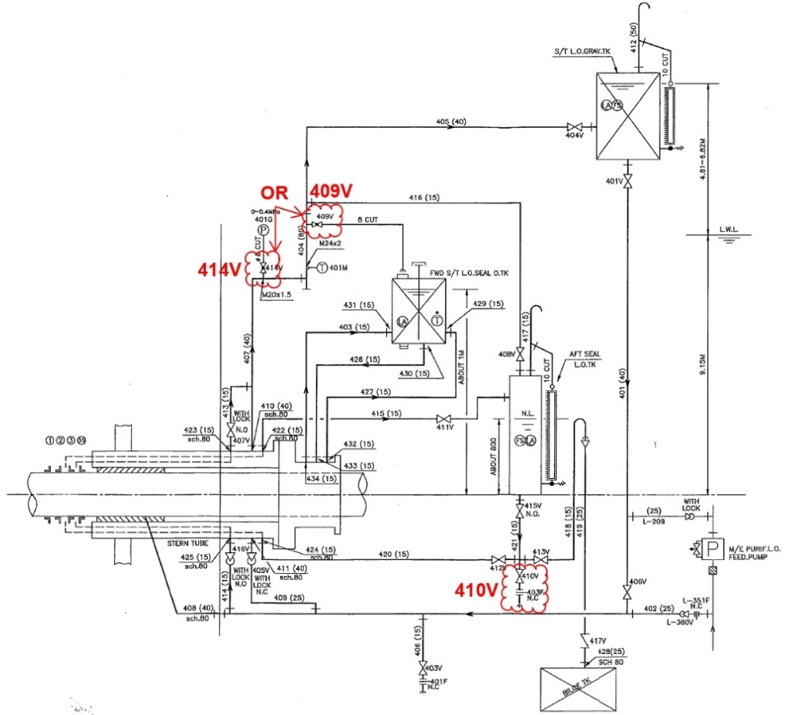
example) Oil Sample Point

ME-Engine Hydraulic Oil Sampling Procedure

        - Ref. Below instruction

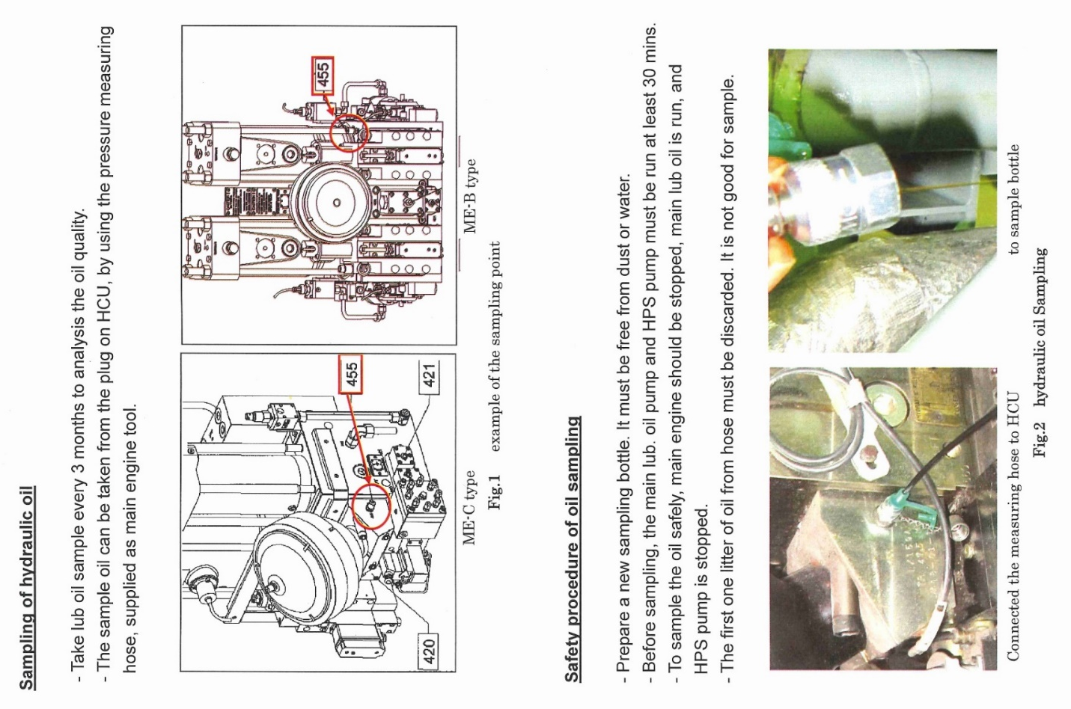

        - Following items of main engine and generator engine system oil to be tested by on board test kit once every month and reported to the office. (ERP-05-09A):

          - Viscosity
          - Water content -Free water (separated from oil), dissolved water (dissolved in oil) can be detected, but bound water (connected with additive) can’t be detected by on board test kit, so water contents analyzed by shore laboratory that can detect bound water is always higher than ship tested one.

(This Bound water tends to increase as the alkali value usually increases, and in the case of main engine system oil, mixing of Cylinder oil can be a major cause of Bound water)

          - TBN (Total alkalinity value)
          - Spot Test

        - Analysis by shore laboratory - Samples to be regularly forwarded to LO supplier’s laboratory according to their instruction. Sample bottle kit to be requested to supply together with LO requisition.

        - Analysis interval by shore laboratory is as follows, but not limited to those in such case as incident, urgent and so on.

          - One every three (3) months

- Main Engine System Oil
- ME-Engine Hydraulic Oil
- Each Generator Engine System Oil
- Stern Tube System Oil

          - Once every Six (6) months

- Turbo Generator System Oil
- Steering Gear System Oil
- Each Deck Hydraulic System Oil (Windlass, Winch, Ramp way & Crane)
- Valve Remote Control Hydraulic Oil
- Each Cargo Oil Pump & Turbine System Oil
- Emergency Generator
- Any other machineries as necessary

        - Countermeasures to be taken by PIC/SI in charge of analysis result

          - Trend of each result (deterioration or improvement) to be focused on.
          - S.I needs to monitor whether sample analysis is being performed as per Company policy. If not being performed, SI must instruct vessel to comply.
          - If there is any doubt on the analysis result, SI should consider re-analysis etc.
          - If deteriorating trend is more than usual, investigating of its cause to be started consulting with machinery and LO maker even before it reaches caution level. This status to be shared with his direct superior and staffs concerned.
          - If analysis result reaches caution level without grasping its trend, necessary measures to be taken to put it back to normal level without delay along with investigation of its cause.
          - Analysis interval to be shorten as necessary to make more close monitoring of deterioration.
          - To check how LO deterioration more than its limit affects machineries and to advise vessel to pay full attention to such machineries.
          - In case of no improvement even though some countermeasures have been taken, drastic measures to be taken to put it back to safety level. There is no such management as deterioration reaches caution level under the situation that analysis result has been carefully monitored since its trend started.

(Refer to After mentioned Table sheet regarding Problems & Possible Causes)

Lubricating Oil Inventory

        - ROB of end of the month to be reported to the company every month. Every precaution to be taken to ensure that the inventory is accurate.

        - Proper LO consumption on all machineries to be monitored by ship’s C/E and PIC and if unusual one is noticed, its cause to be investigated and countermeasure to improve it to be taken without delay consulting with SI in charge as necessary.

Problems & Possible Causes from the Lub. Oils Analysis Result

Problem | Possible Causes
Fuel dilution or low viscosity oil | Defective injectors; worn injection pump; use of lower viscosity lube oil
High viscosity | Excessive insoluble; excessive oxidation; water  contamination; use of higher viscosity lube oil; heavy fuel contamination
Fuel contamination | Defective injectors; worn injection pump
Excessive water | Cooling system leaks; condensation; poor crankcase  ventilation; outside contamination; incorrect purifier operation; tank top leaks
Fresh water contamination | Cooling system leaks; condensation; poor crankcase  ventilation; outside contamination; incorrect purifier operation; tank top leaks
Sea water contamination | Cooling system leaks; outside contamination; tank top leaks
Glycol contamination | Cooling system leaks
Excessive oxidation | High engine temperatures; piston ring blow-by
Excessive insoluble | Poor combustion; excessive blow-by; outside contamination; Inadequate purification; scrape-down material
Low TBN | Poor combustion; excessive blow-by; low rate of oil make-up; dilution with lower TBN oil; high water content; too low engine temperatures
High TBN | Excessive stuffing box leakage of cylinder oil; contamination from higher TBN oil
Presence of Strong Acids (SAN) | Excessive blow-by; low make-up rate; too low engine temperature; leaky turbocharger seals; scrape-down material
Iron level substantially exceeds the average | Machinery component wear; metal to metal contact; corrosion: abrasive contamination
Cooper level substantially exceeds the average | Machinery component wear; metal to metal contact; corrosion; abrasive contamination; stuffing box ring wear; piston-wear-band wear
Chromium level substantially exceeds the average | Machinery component wear; metal to metal contact; corrosion; abrasive contamination
Lead level substantially exceeds the average | Bearing wear; metal to metal contact; abrasive contamination; corrosion; machinery component wear; see note below
Aluminum level substantially exceeds the average | Machinery component wear; metal to metal contact; abrasive contamination; fuel catalyst contamination when silicon level also high
Silicon level substantially exceeds the average | Silicon can be either abrasive material or present as a non-abrasive defoamer; seal material or gasket cement  If wear metals are high, the silicon is usually abrasive  If aluminum level is also high, fuel catalyst contamination may be the cause
Magnesium level substantially exceeds the average | Sea water contamination; see note below
Vanadium level substantially exceeds the average | Blow-by of heavy fuel combustion products; heavy fuel contamination
Zinc level substantially exceeds the average | Zinc contamination can originate from engine oils containing zinc compounds which can be harmful to EMD engines with silver bearings or from zinc coated containers or piping materials
Silver level substantially exceeds the average | Most EMD engines contain some silver bearings. Excessive silver indicates bearing wear
Boron level substantially exceeds the average | Cooling water contamination
Nickel level substantially exceeds the average | Blow-by of heavy fuel combustion products; heavy fuel contamination
Tin level substantially exceeds the average | Bearing wear; metal to metal contact; abrasive contamination; corrosion; machinery component wear; see note below
Competitive products | Usually, analysis data will be reported without comments or recommendations

Note: Metallic compounds of various metals may be in “used engine oils” as a result of contamination from fuels, coolant inhibitors, rust preventives, water and system cleaners. Through Mobil’s “PROGRESSIVE ANALYSYS” type of reporting, the vessel owner/operator should pay particular attention to abnormal “TRENDS”. It is recommended, if time and circumstances permit, that another oil sample be submitted to Mobil’s PFA laboratory to verify abnormal results before taking significant corrective action.

Storage

As per section 5.9.2.f above, LO supply in drums to be avoided as much as possible. Following guidelines to be followed for the LO received in drum (which can not be avoided).

        - The company prohibits storage of drums of Lubricating Oil, Hydraulic oil, chemicals, and any other MARPOL defined pollutant in the forward store/Bosun store on all fleet vessels.

        - Vessels with fixed frames in forward store for storage of drums may do so with proper securing and wedges fitted in-between drums to restrict any movement after approval from the Office.

        - All such pollutant drums must not be stored anywhere on open deck (including midship store top on Tankers).

        - All drums/cans containing Lube oil, hyd oil, chemicals, or any other substances defined in IMDG, and MARPOL shall be stored at a designated covered location with MSDS.

        - In designated covered stores, all such drums stowed shall be securely lashed with wire rope and turnbuckles (with rubber sheathing/thin plywood sheet underneath) to prevent metal to metal contact at all times.

        - Where Lub Oil supply is not available in bulk, including non-availability of drum pumping by supplier, and the drums need to be stored on open deck, such as funnel deck, due to large volume of drums, the following to be ensure before receipt of drums:

          - Pre-planning for storage and lashing of drums in consultation with office.
          - Drums Shall be stored in appropriate location and confirmed by the Master.
          - No more than 2 drums should be secured together with suitable lashing. In case of multiple drums, they should be lashed into groups of not more than 2 drums and all groups to be tightly lashed as a complete unit.
          - Photographs for confirmation of lashing to be sent by vessel or obtained by office before vessel departure from port and confirmed by SI whether lashing is done correctly.
          - Lub Oil from drums must be transferred to storage tank as soon as possible after receiving them onboard, even if the drums are lashed and office informed upon transfer.
          - Lashings should be re-checked, and extra lashing taken, if necessary, before entering area of bad weather.
          - Designated staff on board must confirm the physical condition of drums at least once in 3 days and record the same to ensure that drums are intact and not leaking when stored on deck till such time that the contents are transferred to the storage tank.

-x-

